RESOLUTION NO.__________

RE: CERTIFICATE OF APPROPRIATENESS UNDER THE
PROVISIONS OF THE ACT OF THE PENNSYLVANIA
LEGISLATURE 1961, JUNE 13, P.L. 282 (53
SECTION 8004) AND BETHLEHEM ORDINANCE NO.
3952 AS AMENDED.

WHEREAS, it is proposed to install Larson Gold Series Aluminum Storm Windows in white to the windows on the first, second and third floors at 78 W. Market St.

NOW, THEREFORE, BE IT RESOLVED by the Council of the City of Bethlehem that a Certificate of Appropriateness is hereby granted for the proposal.

Sponsored by: (s)

(s)

ADOPTED BY COUNCIL THIS DAY OF

(s)
President of Council

ATTEST:

(s)
City Clerk

HISTORICAL & ARCHITECTURAL REVIEW BOARD

APPLICATION #1: The applicant proposes to install storm windows on the front facing windows excluding the basement level at 78 W. Market St.

OWNER: Matthew Lapos
78 W. Market St., Bethlehem, PA 18018
__________________________________________________________________

The Board upon motion by Phil Roeder and seconded by Holly Sachdev adopted the proposal that City Council issue a Certificate of Appropriateness for the following:

- Install Larson Gold Series Aluminum Storm Windows.

- Color to be White and installed on the first, second and third floors of the front façade.

3. Basement windows are not included in above work.

4. The motion was unanimously approved.

__________________________________________________________________________

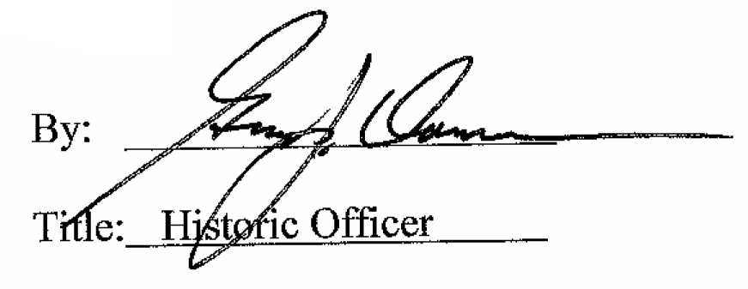

Date of Meeting: January 7, 2015

